APPLICANT/CANDIDATE RESUME

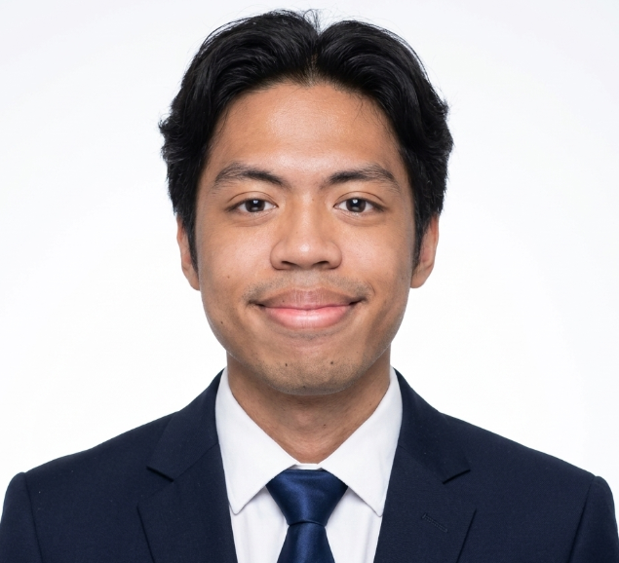
CONTACT INFORMATION
Janritch D. Diputado
A-190 B. Aranas St., Cebu City
09458674286
janritch@gmail.com

PERSONAL INFORMATION
Filipino
Male
Single
22 years old
Speaks and writes: English, Cebuano
Computer PMS and Software skills
- Word Processing (Google Docs, Google Sheets, Word, Excel)
- Web Development (Backend, Frontend, AI)

EDUCATIONAL BACKGROUND
1. Bachelor of Science in Computer Science
2023 - 2027
University of San Carlos - Talamban Campus

2. Senior High School - ABM
2021 - 2023
Sacred Heart School - Ateneo de Cebu

3. High School
2017- 2021
Sacred Heart School - Ateneo de Cebu

CERTIFICATIONS & ACCREDITATIONS
CCNA: Introduction to Networks
CISCO Networking
May 2025

STRENGTHS/TRAITS & SKILLS
- Experience real work environment
- Able to work under high stress environments
- Good interpersonal skills
- Able to work within tight schedules

CAREER OBJECTIVES
Get a stable career path, and be able to live a comfortable life while raising a family

References

- Ritchie Diputado
Chief Technology Officer
EvoTech Software Solutions Inc. Cebu City Philippines
Contact Number

Resume updated on 26/07/2026

